# Iteration 2 – Development log

This iteration will be all about the front-end and making the appearance of the website looking good.

Firstly, I imported the Poppins font from Google Fonts using the link in my design document. Google automatically provides you with some base font classes and the import code for the CSS. I put this into my CSS and began to create a basic navbar which looked like my design.

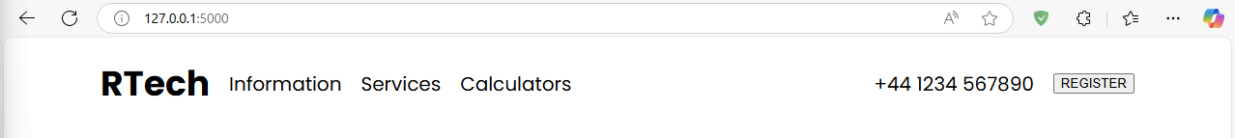

After a few minutes, the above is what I ended up with. There are some tweaks required here, but I’ll go over the code.

The navbar is contained in the common HTML template and therefore will be shown on every page. The HTML structure for the navbar is the following:

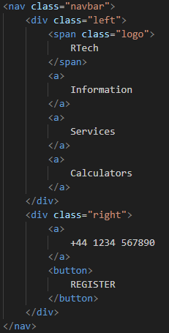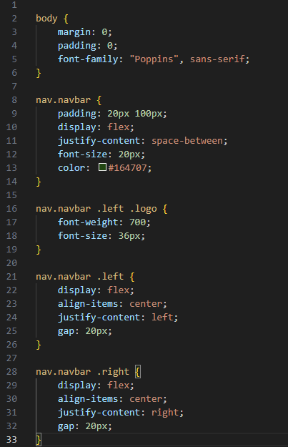

I then wanted to style the buttons, so I worked on that and ended with the following result:



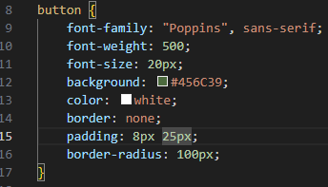

I thought this looked nice, but lacked interactivity and responsiveness, so I added some cool animations.

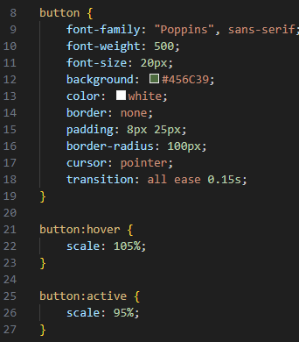

Now, when the button is hovered, it slightly increases in size, and when you hold click on it, it slightly reduces in size. This, coupled with an easing transition over 0.15s creates a very satisfying animation.

I then added a link to the button so that it redirected the user to the register page.

I also added a link to the logo in the navbar, which is text. I then realised that links are still not properly styled:



So, to fix this, I will change the colour and remove the underline. Now, I have this:

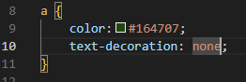

Next, I made it so that if the user is logged in, it properly displays their name instead of a register button. Here’s how I did it for the landing page:

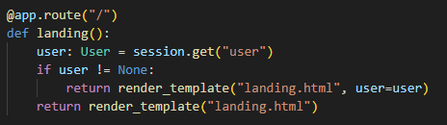

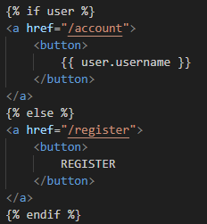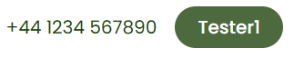

I also wanted to keep my CSS file organised, so I started using variables instead of typing the HEX codes each time. I also documented which areas of the documented affected what things.

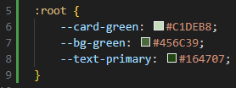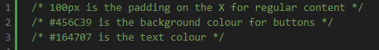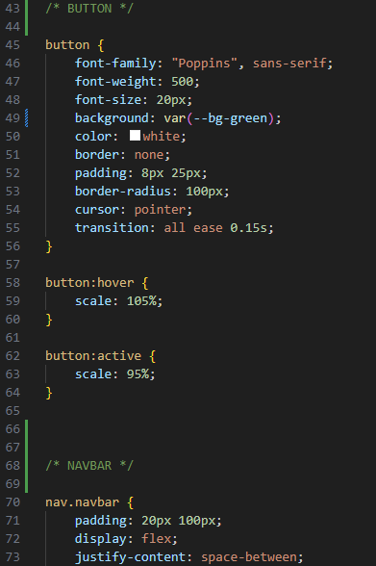

The next thing I realised was that the register and login forms are still very bad at providing user feedback, as currently the system prints out the errors rather than showing them to the user. That is what I am going to change now.

After testing, I came up with this card example:

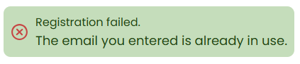

Now I must use variables and jinja to make it come to life.

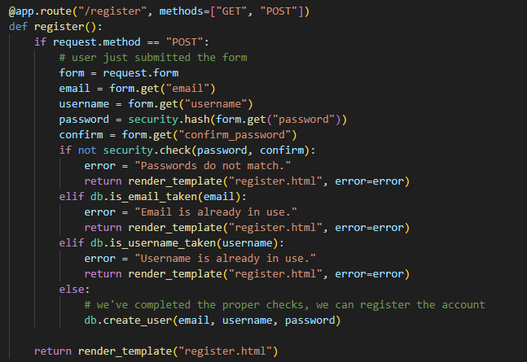

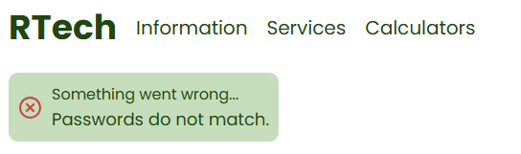

Now the errors are properly shown for the registration page. Now I am going to do the same for the login page.

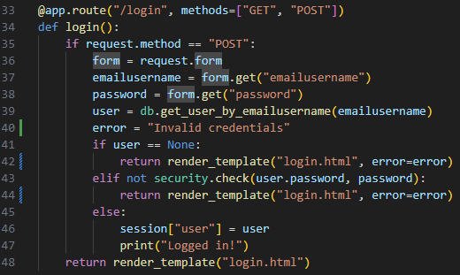

Now both the register and login forms properly give user feedback when errors occur. I will now move onto styling the actual forms themselves.

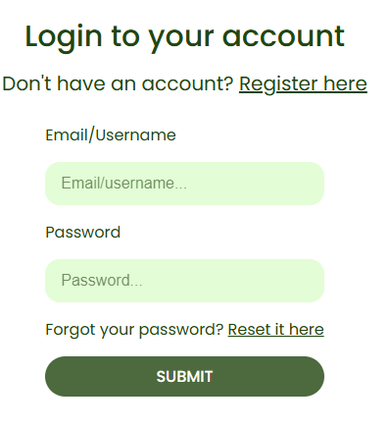

I ended up with this for the login form. It’s an almost exact replica of what was designed in Task 1. I haven’t got around to doing the registration form yet, as it’s got a slightly more complicated layout. Instead, I am going to work on the login form more. The first thing I want it to do is to disable its inputs when a submission is going through. This will stop the user from spamming submit and changing their submission whilst its processing.

I will have to use JavaScript to achieve this effect.

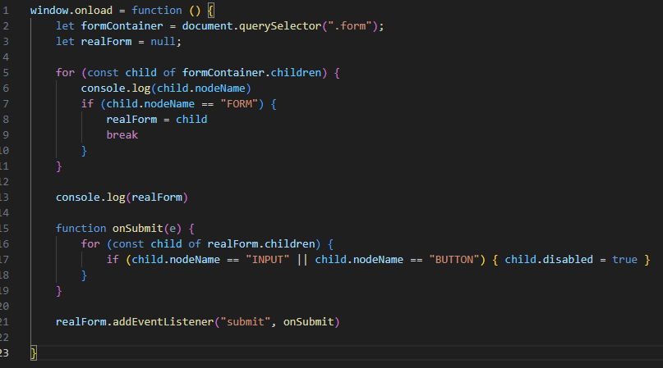

This is the JavaScript I used to disable the form when it gets submitted. It also disables the submission button so it can’t be spammed with multiple requests at one time.

The next thing I’m going to do is sort out the landing page. It needs to look exactly like the designed page. I also worked on some responsive design whilst doing it:

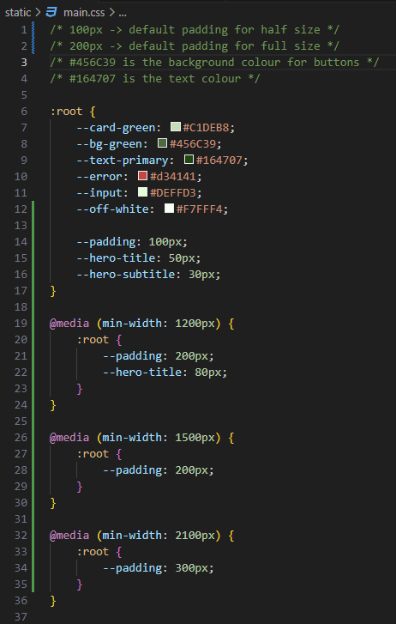

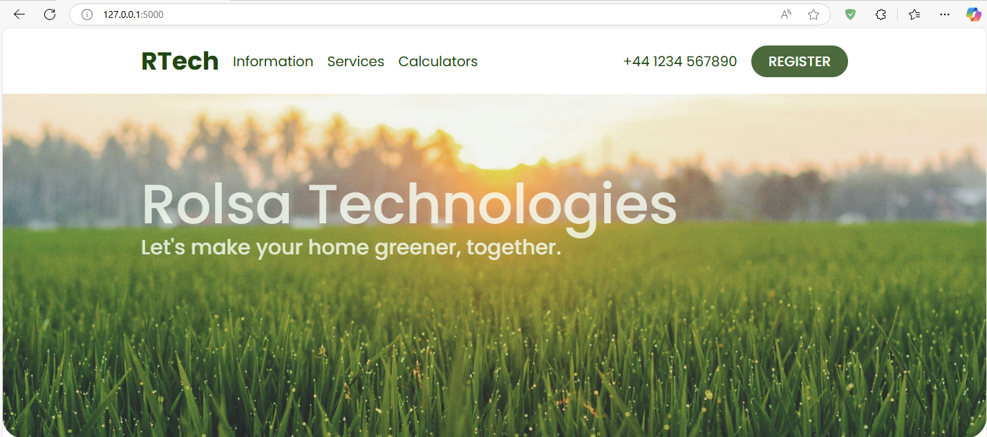

The next thing I am going to develop is the navbar. The information, services, and calculator options in the navbar need to be dropdowns that show actual links when they are hovered. I will do this now.





There’s also a very nice animation when you hover over them.

The next thing I’m going to do is the banner. This fits in between the navbar and the content of each page, showing some basic information to the user.

Here’s what it looks like on the landing page:



I think it’s very good.

Next up, I’ll create the footer that will be on every page.

This is how it looks on the landing page:

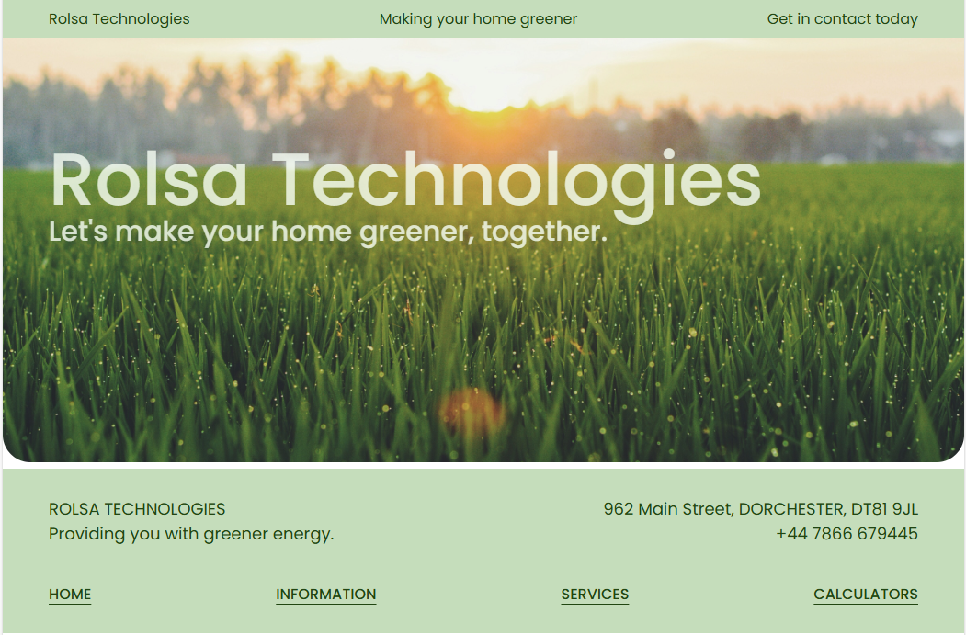

It looks a bit strange, but that’s because there’s not any content on the landing page yet (we will do that next!).

Here’s how I implemented the footer:

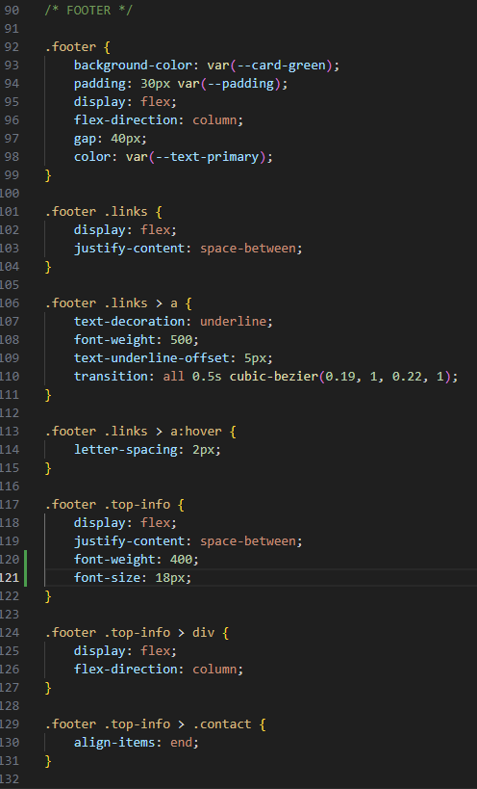

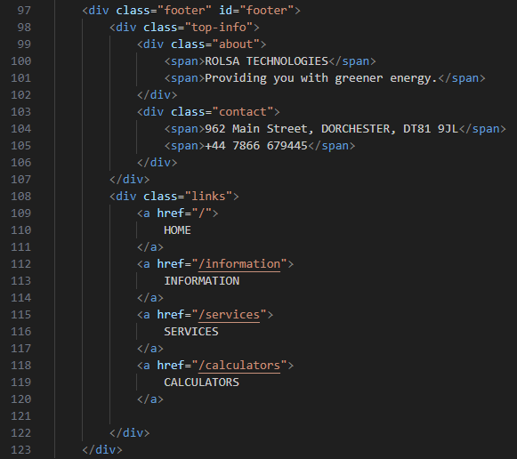

Now, I’m going to add content to the landing page and make it a bit more exciting.

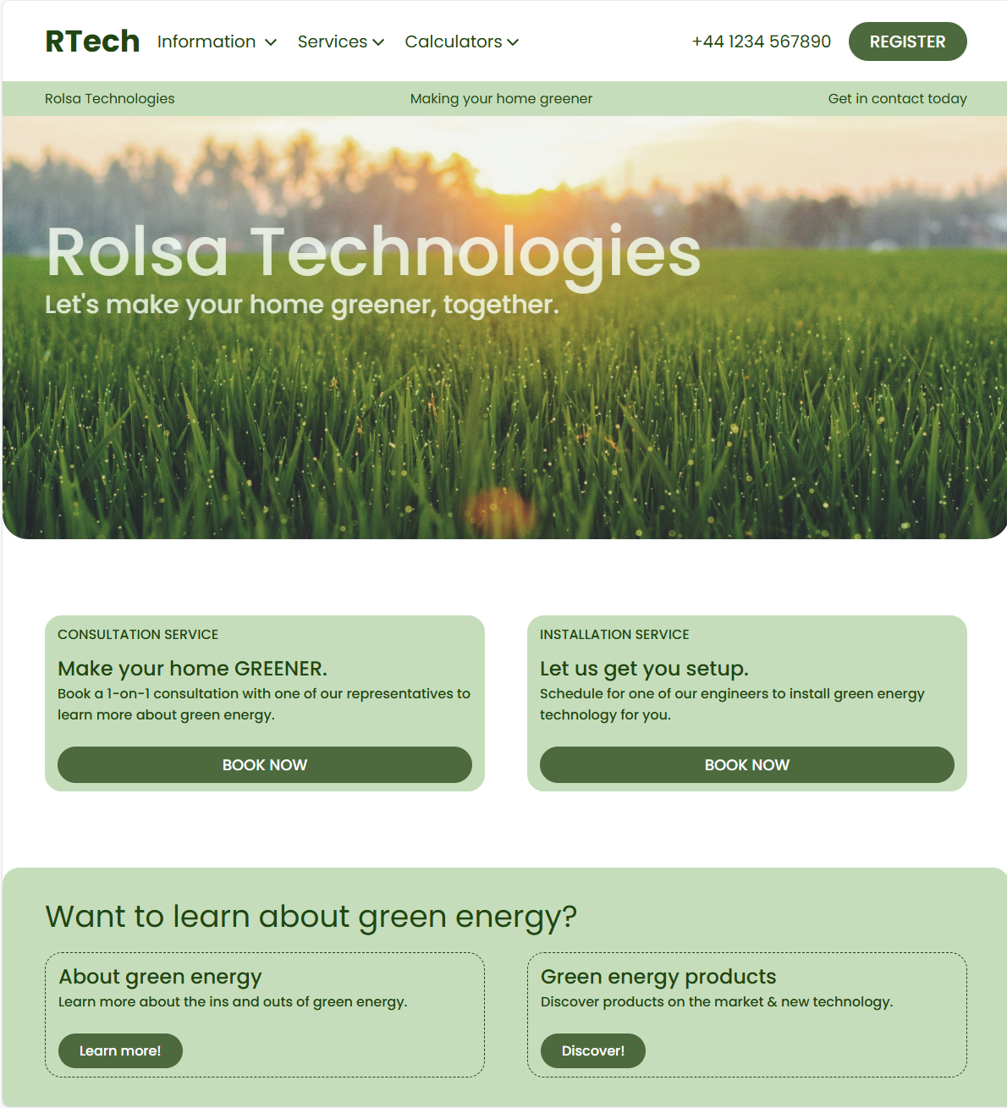

This is how the landing page currently looks. I think it looks much better with all of the content.

Below is the HTML: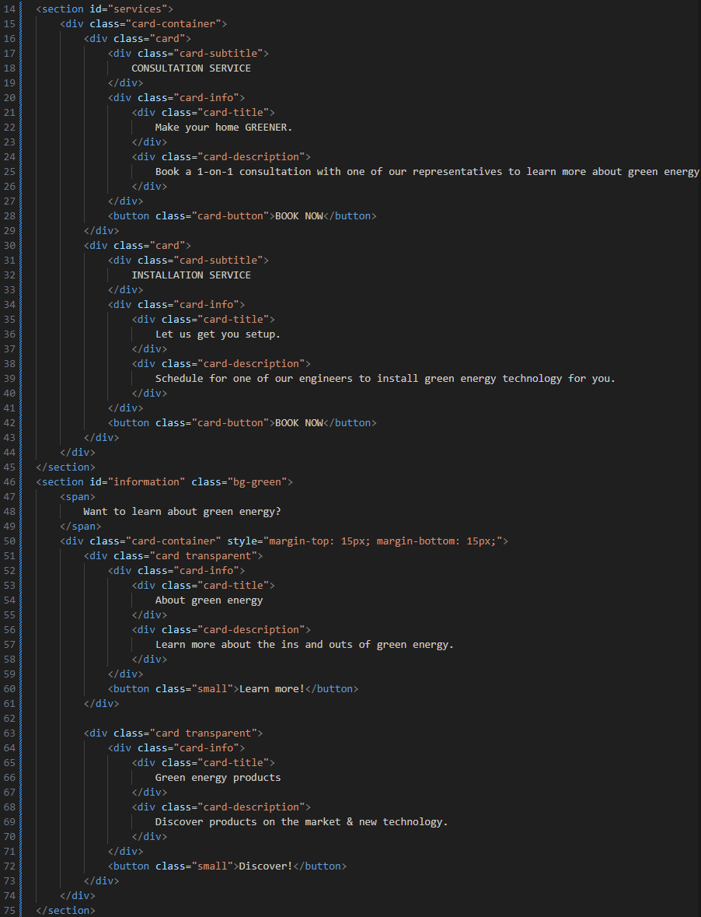

Next, I am going to make all the pages for all the content that needs to be in the application. This includes the informational pages, the services pages and the calculators.

Here are all of the pages in the explorer view:

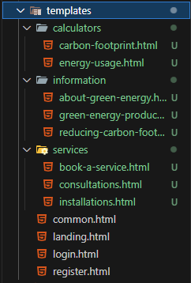

I now need to go into each one and create the default content. Then I will create routes for them in the “app.py” file.

After a few days break, I have a fresh perspective of the website, and I need to make some changes.

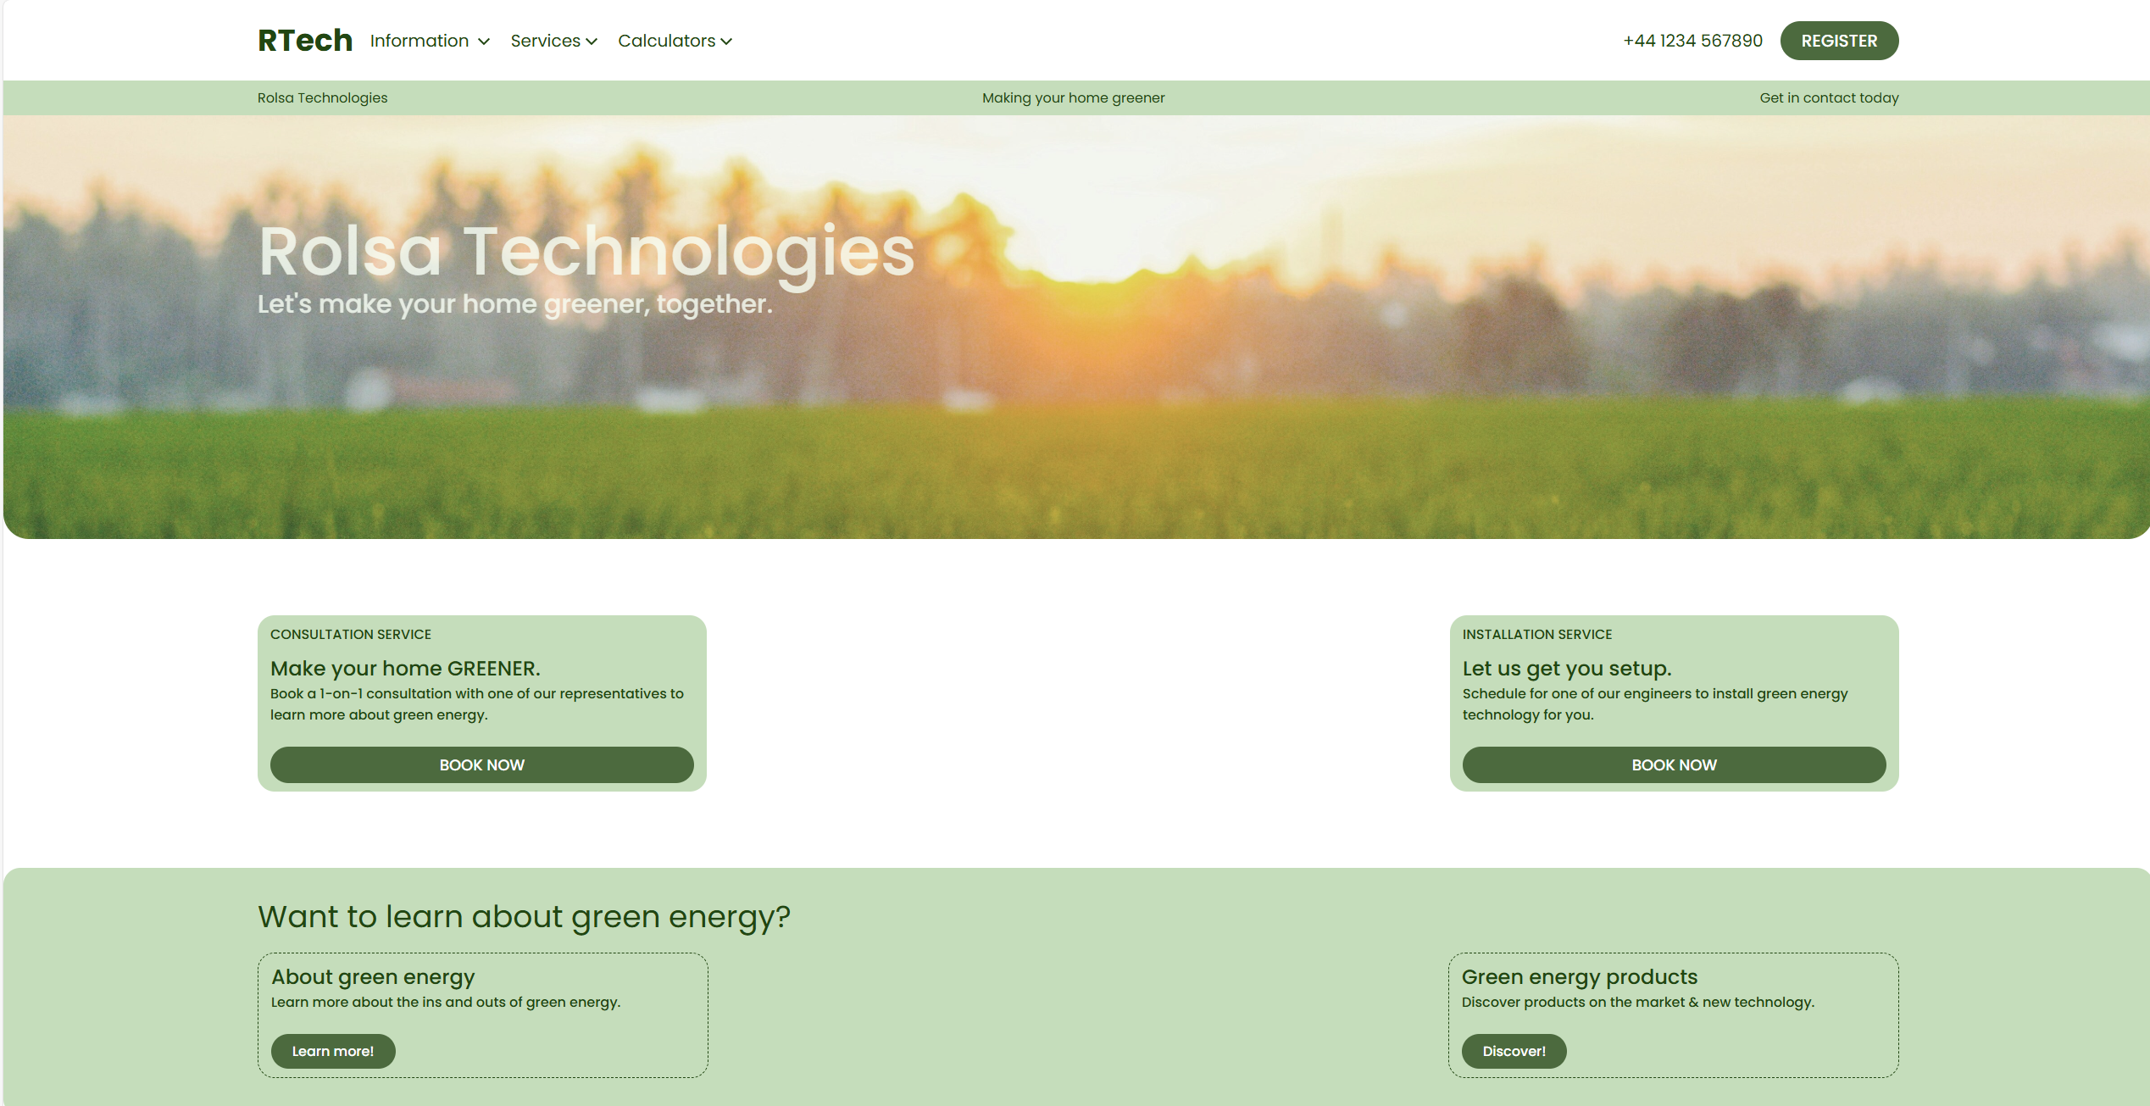

Firstly, this is what the screen looks like full screened. I think the cards are way too far apart, so I need to either add more of them, or make them bigger. I will make the first two bigger and add more to the bottom two.

I also removed the dashed lines around the cards at the bottom and used an animated shadow instead.

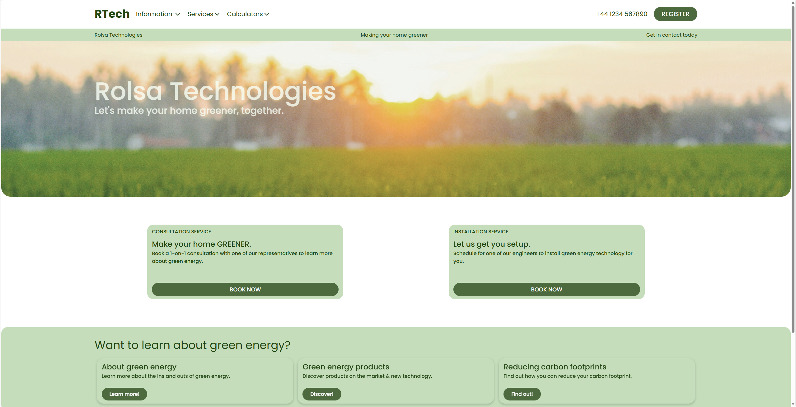

Next, I wanted to make the navbar responsive. This means when the screen gets too small, it hides certain elements to make room.

That’s all done now. Here’s some of the code.

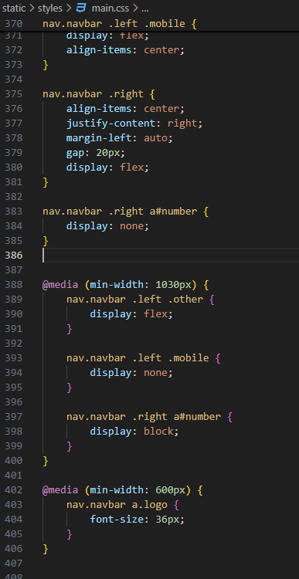







Next, I wanted to make everything else responsive. From testing, I can see the banner needs some work.

I did this by removing the middle element when the screen was too small.

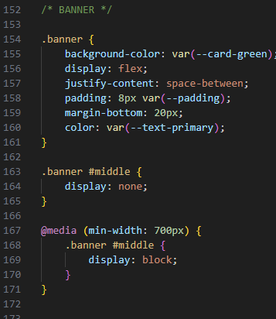

The next thing that needs to be responsive is the hero text. I will just reduce the font-size when the screen is too small.